SETs

Sets are iterable, orderless, have only unique values.

Define:

new Set{ iterable
}

eg
new Set(‘a’ ‘b’, ‘c’);

new Set(‘String’);

new Set(array);

Functions:

.size()
(not length like in arrays)

.has(‘search string’)
(arrays have include)

.add(‘what to add’)

.delete(‘what to delete’)
(no equiv method for arrays)

.clear()
(delete all elements)

How to retrieve values?

Using index?
No. Sets don’t have order, hence no index, and hence
there is no point in retrieving a value from set, just check for its presence.

Uses Case
1. Removing duplicates from an array

const newUniqueArr = [...new Set(oldArr)];

2. They have a lot of methods to manipulate elements in them

MAPs

Maps keys and values. Like in objects.
Difference: keys can be of any type (even objects and arrays). In objects they are only string.

Define:

new Map{
}

or

new Set([

[‘key’, ‘value’],
[‘key’, ‘value’]

]);

Functions:

.size()
(not length like in arrays)

.has(key to search for)
(arrays have include)

.set(index, data)
// returns a Map
// hence chaining is possible

eg…
amap.set(...).set(...).set(...)…

another eg.

amap.set([1, 2], ‘value’); ❌
then we won’t be able to acces it again…

newMap.get([1,2])
will return undefined because the two arrays are different.

You want to do it in this way:

const arr = [1, 2];
amap.set(arr, ‘value’); ✅
newMap.get(arr)

.get(key)
// returns corresponding value

.delete(key)
(no equiv method for arrays)
also present in objects, slow, not recommended

.clear()
(delete all elements)

Questions:
Easy way to define Maps. ✅
Study how refrencing works on primtive and reference data types in JS.

MAPS Creation

Easy way to create maps

const question = new Map(
[
[‘index’, ‘value’],
[‘index’, ‘value’],
[‘index’, ‘value’],
[‘index’, ‘value’]
]
);

Note that this is same array structure returned from Object.entries().

Hence, creating Maps from objects:
new Map(Object.entries(object));

Map to array
const new array = [...Map]
(of arrays consiting of key values pairs)
const new array = [...Map.keys]
(of arrays consiting of key)
const new array = [...Map.values]
(of arrays consiting of values)

Iteration
Maps are iterable.
Hence we can use for of loop

for (const [key, value] of map) {
}

When to Use Case what data structure?

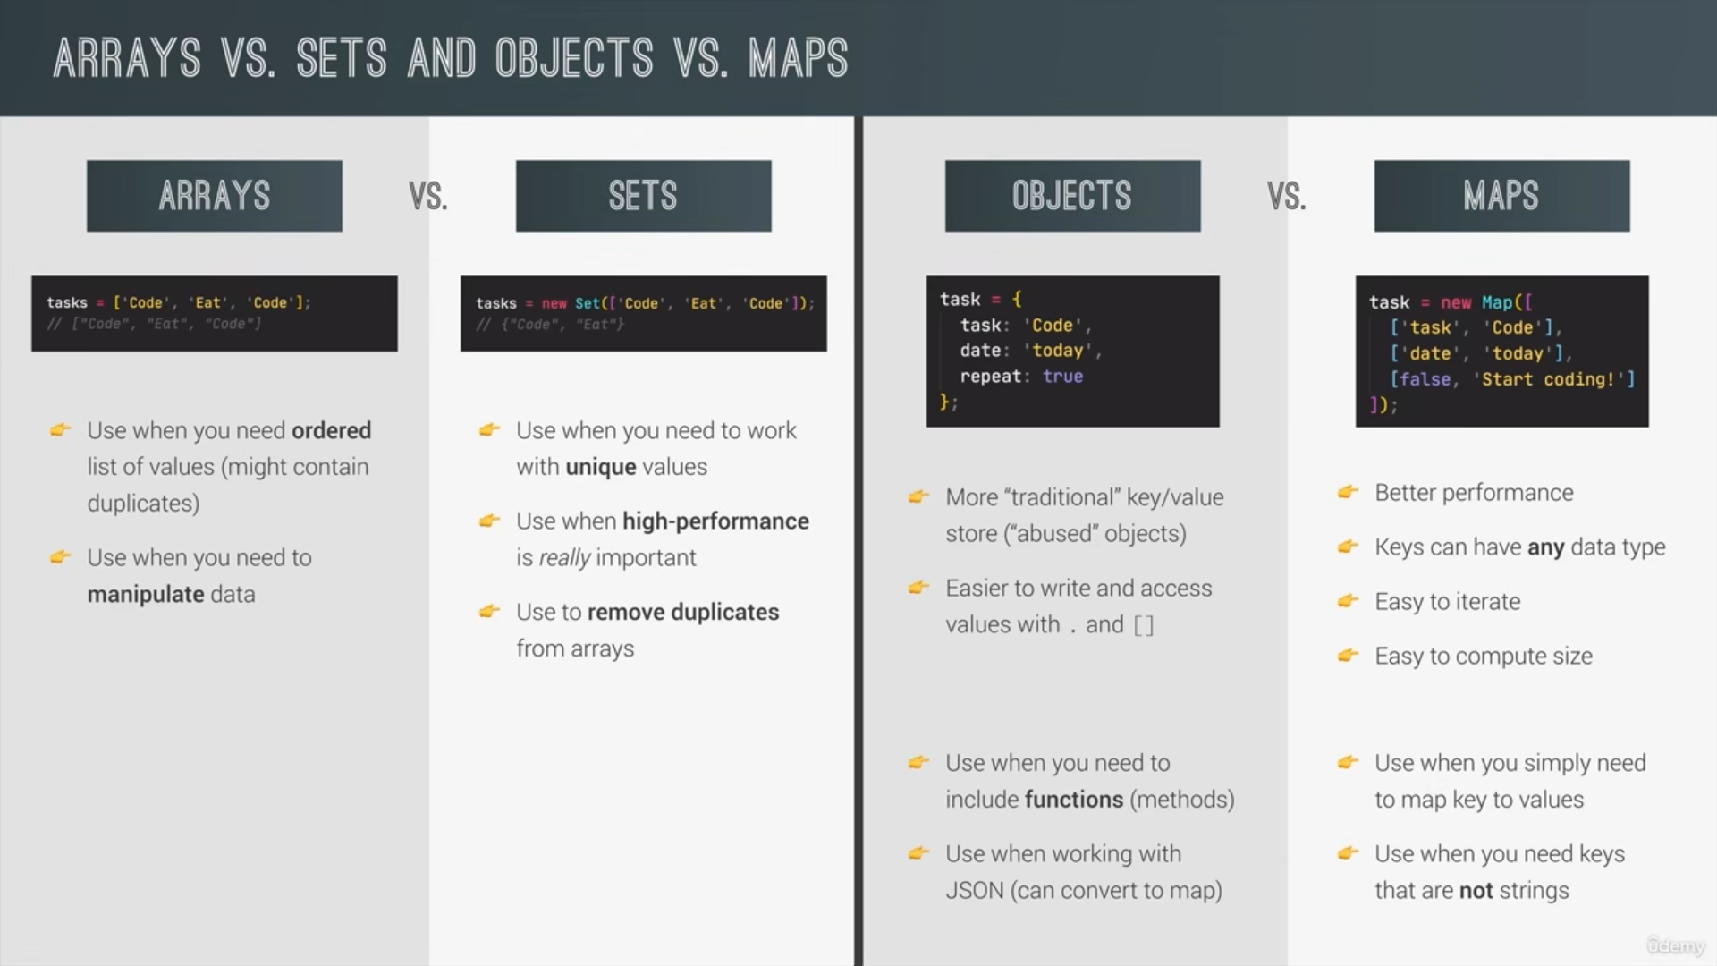
Maps don’t have methods!
Sets are faster (10x) in adding and removing elements.

Strings

Array like operations:
Indexing:
‘string’[3] gives i.
Output is also a string, not a char (it is not present in JS).
NOTE: STRINGS ARE IMMUTABLE HENCE str[i] can’t be a lvalue.
Length:
‘string’.length gives 6

Finding index of substring/characters:
indexOf(‘string’)
lastIndexOf(‘string’)

Slice method:
Used to get substrings. No mutation to original string.

.slice(beginingIndex, endIndex)
beginingIndex is the starting index of slicing, we get a new substring.
endIndex is not included.

NOTE: Length of the output string = endIndex – beginingIndex

We can also use a negative index.
These indexes start from the end (left).
.slice(1, -1);

Behind the scene:
Strings are primitive data types, yet they have methods like objects! How?
A process called boxing happens when we call a method on string.
Boxing refers to creating an object of something like string.
Done using new String().

Other methods
These do not mutate the original string
.toLowerCase()
.toUpperCase()
.trim() // removes whitespaces
There are also trimStart and trimEnd.

Replacing
.replace(‘what to replace’, ‘will replace’);
Replaces only the first match. Use
.replaceAll()
or regex
.replace(/regex expression/g, ‘will replace’);
g→ global flag.

Boolean methods
includes(); like in arrays
.startsWith();
.endsWith();

Split method
Splits a string around a string and yields an array.

Join method
Does opposite of split. Joins an array of string by some specied string.

Padding
.padStart(lenght, ‘what to pad’)
.padEnd(lenght, ‘what to pad’)

